NAME: YERUKONDA VENKATA SHIVA NIKHIL

REG NO. : 39111130

PROJECT NAME: HEART DISEASE PREDICTION USING MACHINE LEARNING

**FLOW DIAGRAM :**

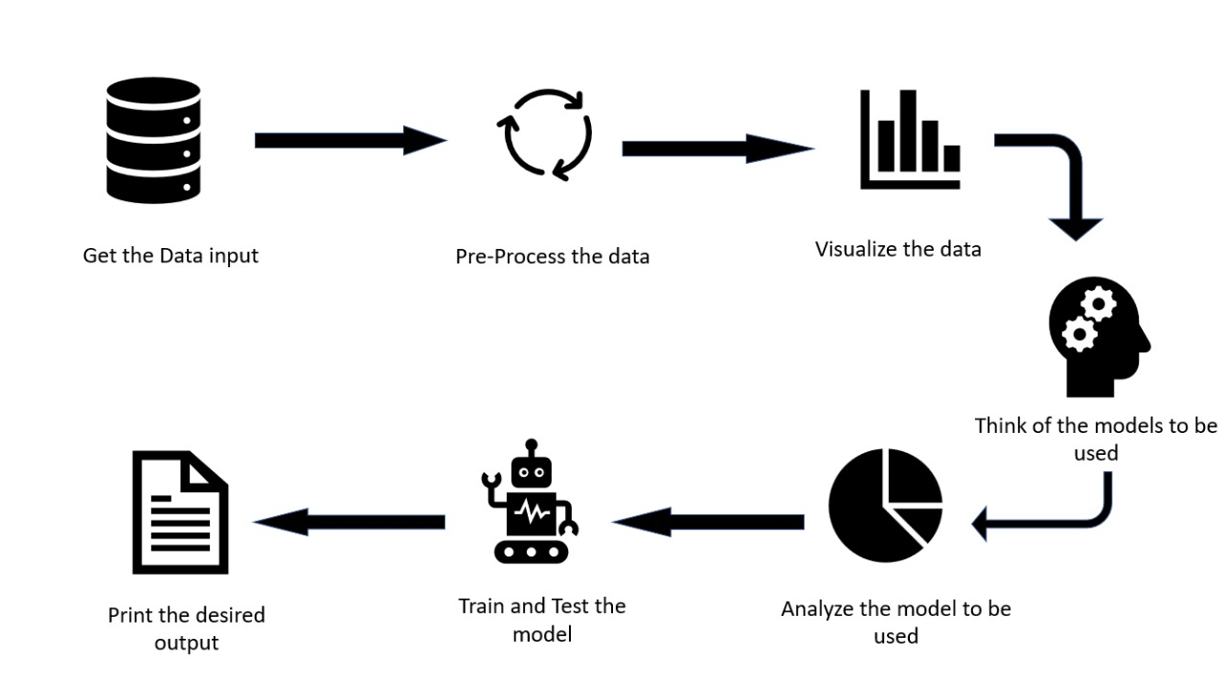

**ABSTRACT :**

Heart-related diseases or Cardiovascular Diseases (CVDs) are the main reason for a huge number of death in the world over the last few decades and has emerged as the most life-threatening disease, not only in India but in the whole world. So, there is a need fora reliable, accurate, and feasible system to diagnose such diseases in time for proper treatment. Machine Learning algorithms and techniques have been applied to various medical datasets to automate the analysis of large and complex data. Many researchers, in recent times, have been using several machine learning techniques to help the health care industry and the professionals in the diagnosis of heart-related diseases. Heart is the next major organ comparing to the brain which has more priority in the Human body. It pumps the blood and supplies it to all organs of the whole body. Prediction of occurrences of heart diseases in the medical field is significant work. Data analytics is useful for prediction from more information and it helps the medical center to predict various diseases. A huge amount of patient-related data is maintained on monthly basis. The stored data can be useful for the source of predicting the occurrence of future diseases. Some of the data mining and machine learning techniques are used to predict heart diseases, such as Artificial Neural Network (ANN), Random Forest and Support Vector Machine (SVM).Prediction and diagnosing of heart disease become a challenging factor faced by doctors and hospitals both in India and abroad. To reduce the large scale of deaths from heart diseases, a quick and efficient detection technique is to be discovered. Data mining techniques and machine learning algorithms play a very important role in this area. The researchers accelerating their research works to develop software with the help of machine learning algorithms which can help doctors to decide both prediction and diagnosing of heart disease. The main objective of this research project is to predict the heart disease of a patient using machine learning algorithms.

**GITHUB LINK :**

https://github.com/nikhilyerukonda/Heart-disease-prediction-using-machine-learning